**Exercise: Pods**

Pods are the smallest, most basic deployable objects in Kubernetes. A Pod represents a single instance of a running process in your cluster. Pods contain one or more containers, such as Docker containers. Although you want deploy pods directly (static pods), knowledge for defining pods manifest files will be used for defining more complex Kubernetes resources like Controllers.

**Practice1: Simple pods operations.**

1. Login to Azure and connect to your AKS cluster.

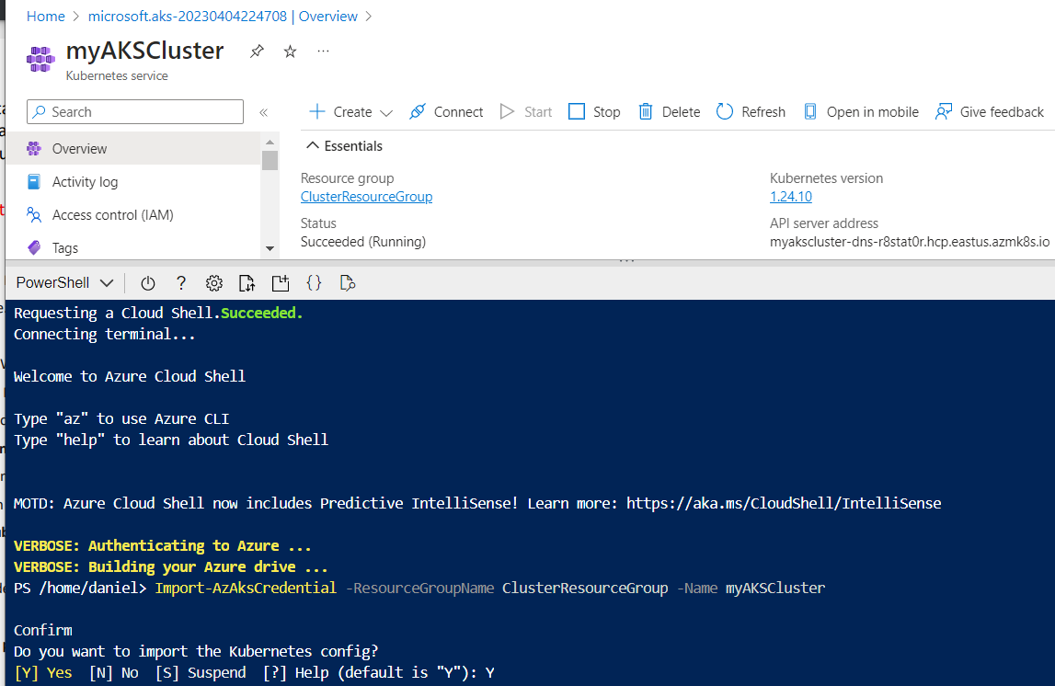

2. Check how many pods run under the default namespace. Run kubectl get pods.



3. You should not see any pod under the default namespace. Now check all namespaces. Run kubectl get pods –all-namespace.

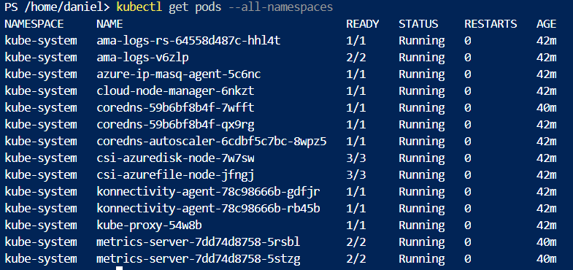

4. How many pods do you see? Who deployed these pods? Why are they deployed?

- 14 pods. Automatically deployed by the Azure Kubernetes Services (AKS). They are deployed in order for our cluster to function properly and perform it’s tasks.

5. Now deploy you first pod using the imperative approach. Run kubectl run nginx --image=nginx.



6. Validate if the pods has been created. What is the status of your pod? – It has been created and it’s status is Running.

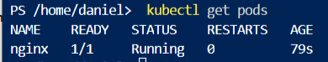

7. Check the logs coming out of your pod. Run kubectl logs nginx.

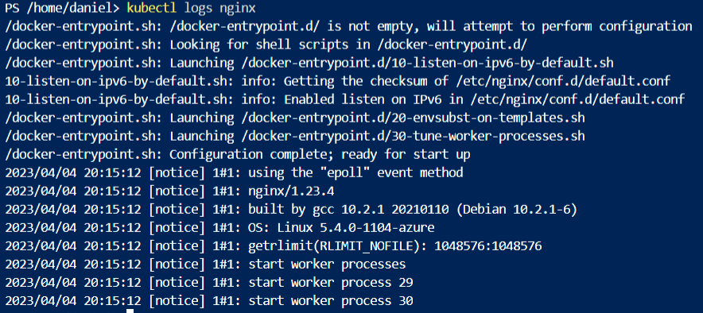

8. Run following command to check current resource consumption of your pod: kubectl top pod nginx.

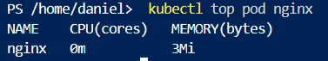

9. Check on which Node your pods has been scheduled. Run kubectl get pods –o wide.



10. Try to find the same information but this time running kubectl describe pod nginx.

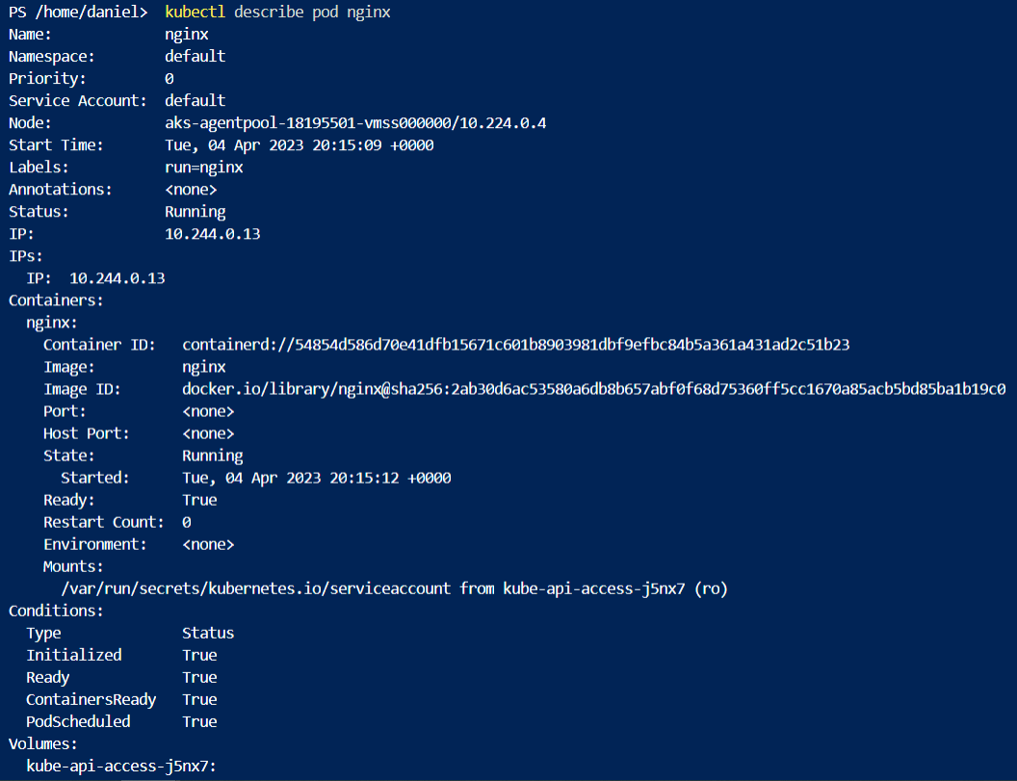

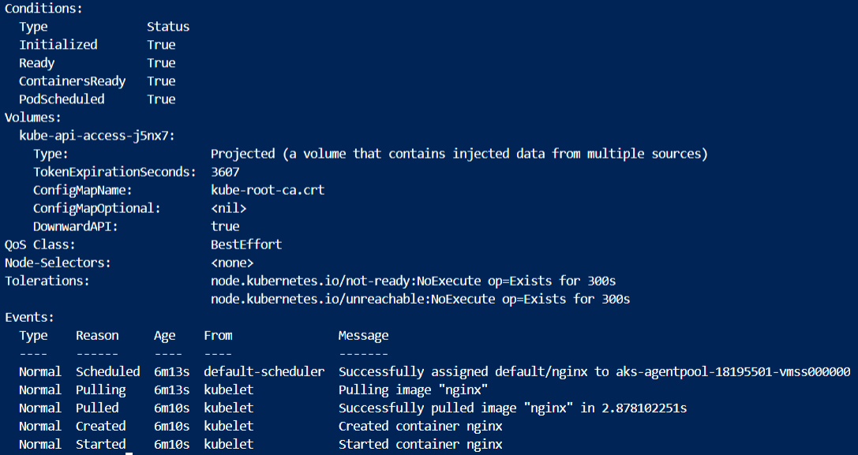

11. Delete your pod using kubectl delete pod nginx.



12. Let’s find the image used on one of the coredns pods under the kube-system namespace.

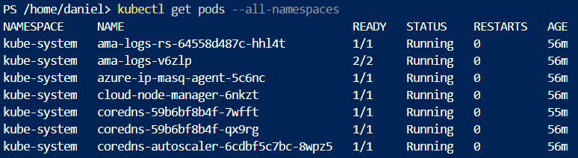

13. Once again list all pods under all namespaces.

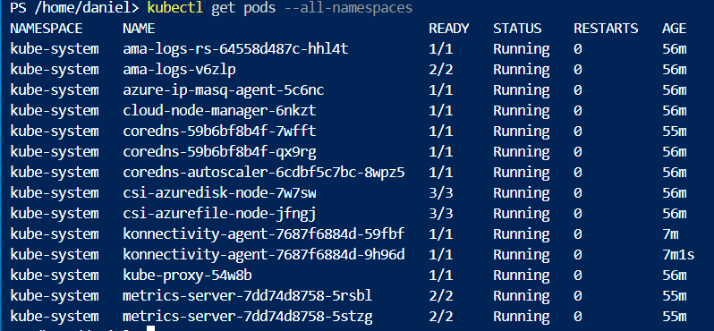

14. Note one of the coredns pods. Now run kubectl describe pod -n kube-system. Replace the place holder with noted name.



15. Inspect the output and locate the image information.

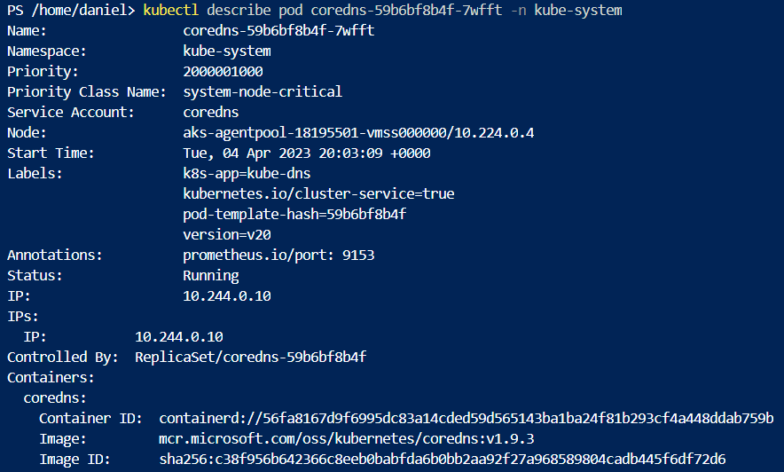

16. Now let us check the logs of the metrics-server pod. Run the same command as in step 7 but don’t forget to add the namespace in which this pod is created.

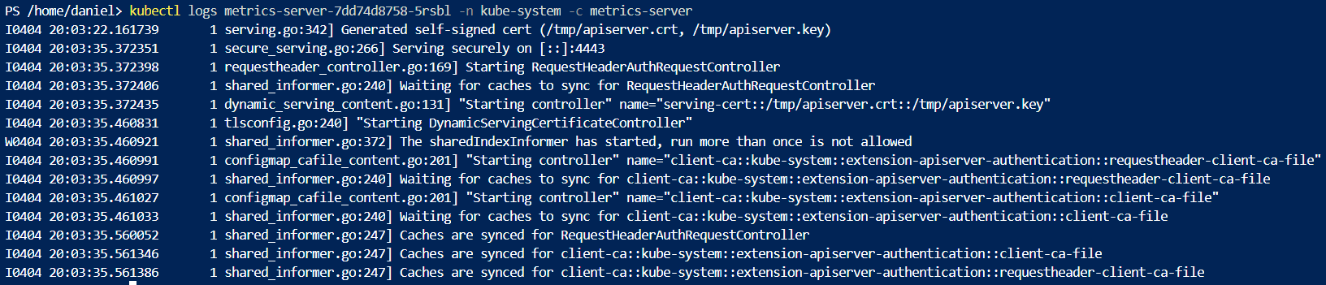

**Practice2: Working with pod manifest files.**

1. Now it is time to deploy pod using manifest file (declarative approach). Copy the following code block on your local computer in a file called redis.yaml:

**apiVersion: v11  
kind: pod  
metadata:  
name: static-web  
labels:  
role: myrole  
specs:  
containers:  
- name: redis  
image: redis123**

2. Try to deploy the pod defined in redis.yaml. Run kubectl create –f redis.yaml.

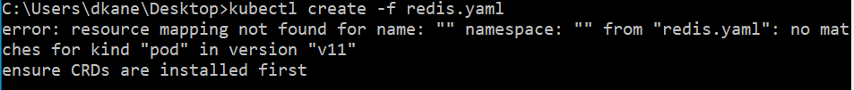

3. You will receive errors on your screen. Your next task will be to correct the syntax of the code you just copied. You can use the online Kubernetes documentation or you can search the internet in general.

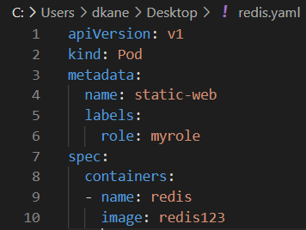

4. When you solve all the syntax errors your pod should be deployed but is it running? What is the status of your pod? – Status is ErrImagePull.

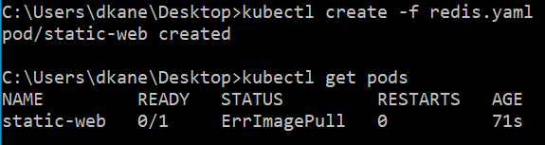

5. Check the events associated with this pod. Run the kubectl describe pod static-web command. What are the events showing? Why your pod is not running? – redis123 cannot be pulled from the registry.

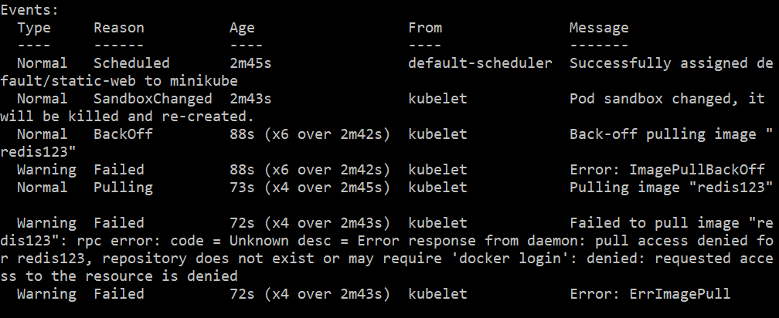

6. Find the correct image (check the Docker hub page) and correct it in the manifest.

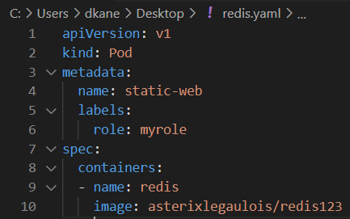

7. Locate the image information and put the correct image name. Redeploy the pod (fist run kubectl delete pod static-web to delete the pod, then run kubectl create once again).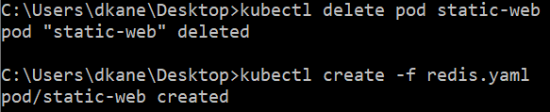

8. Check the status of your pod. It should be running now.

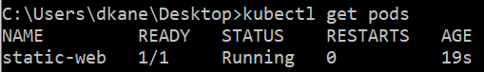

9. Now you can delete the pod. Try to delete it using the kubectl delete –f redis.yaml.



10. Your next task is to create and test nginx pod definition. Your definition should use the nginx official image, should use label named app with value frontend and should publish port 80. Make sure you complete this task because we will use this template in our next Labs. Your nginx pod should be running without any issues.

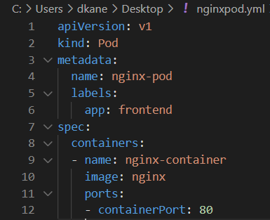



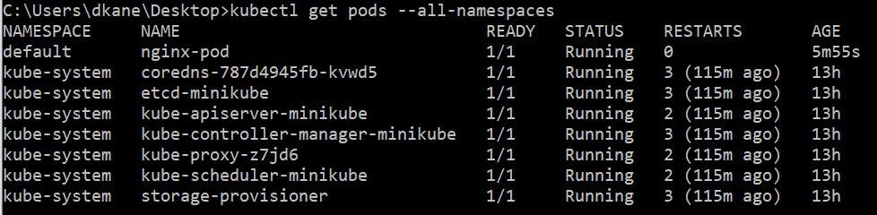

11. Final task of this practice will be to define pod definition with following details:

TO BE ADDED LATER